Student Name: Marco Ermini  
Email: mermini@asu.edu  
Submission Date: 11th Jun, 2021  
Class Name and Term: CSE548 Summer 2021

Project Report 4 - Machine Learning-Based Anomaly Detection Solutions Project Overview

In this lab I am using the NSL-KDD dataset, which is a refined version of KDD’99 dataset, with the purpose of running two labs for data pre-processing, training and testing using Anaconda, TensorFlow and FNN. NSL-KDD dataset is now considered as one of most common for network traffic and attacks, and it is a benchmark for modern-day internet traffic.

All the files and configurations used for this lab have been uploaded on GitHub; references are provided throughout the text and in the Appendix A at the bottom of the file.

# Network Setup

Please find below the initial set-up of the virtual infrastructure as I have configured it in VirtualBox for this VM – it is simply connected via NAT.

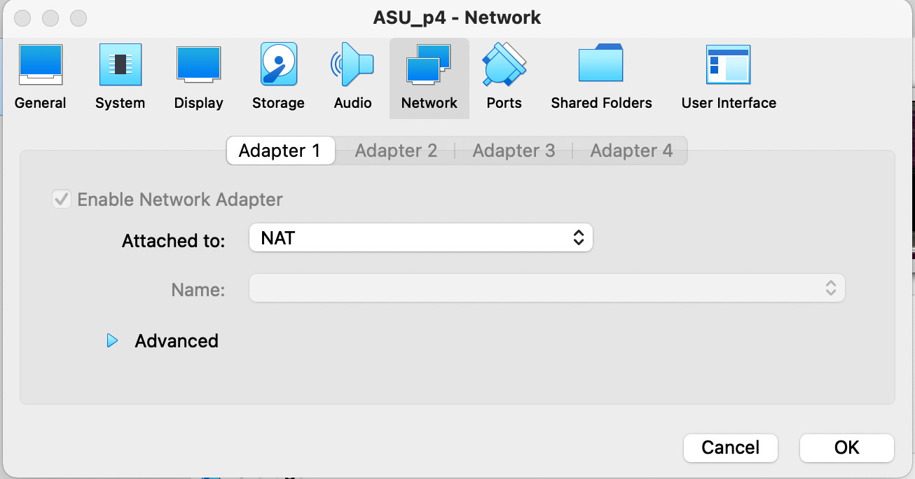

Figure - Bridged network setup in VirtualBox

# Software

For this first lab, the following software has been used:

* Ubuntu 18.04 LTS
* Python – <https://www.python.org/>
* Anaconda - <https://www.anaconda.com/>
* TensorFlow - <https://www.tensorflow.org/>
* NSL-KDD dataset - <https://www.unb.ca/cic/datasets/nsl.html>

# Project Description

In this assignment, I have executed the various labs assignments, obtaining the proofs that they have been successfully completed.

The first lab (CS-ML-00201) a supervised Machine Learning (ML) approach is proposed, where Feed-forward Neural Network (FNN) solutions are used. The dataset used as input, NSL-KDD, provides labeled normal network traffic and labeled attack network traffic. FNN will use the well-labeled data to build FNN-based data pattern to differentiate normal and abnormal network traffic. After training, we use similar data set with labeled data to validate the accuracy of the generate anomaly detection pattern.

## Run the provided fnn sample.py python program with different NSL-KDD datasets as the input, and compare their detection accuracy

I have created the Python code to allow using the different training data by just changing a couple of comments, as shown below:

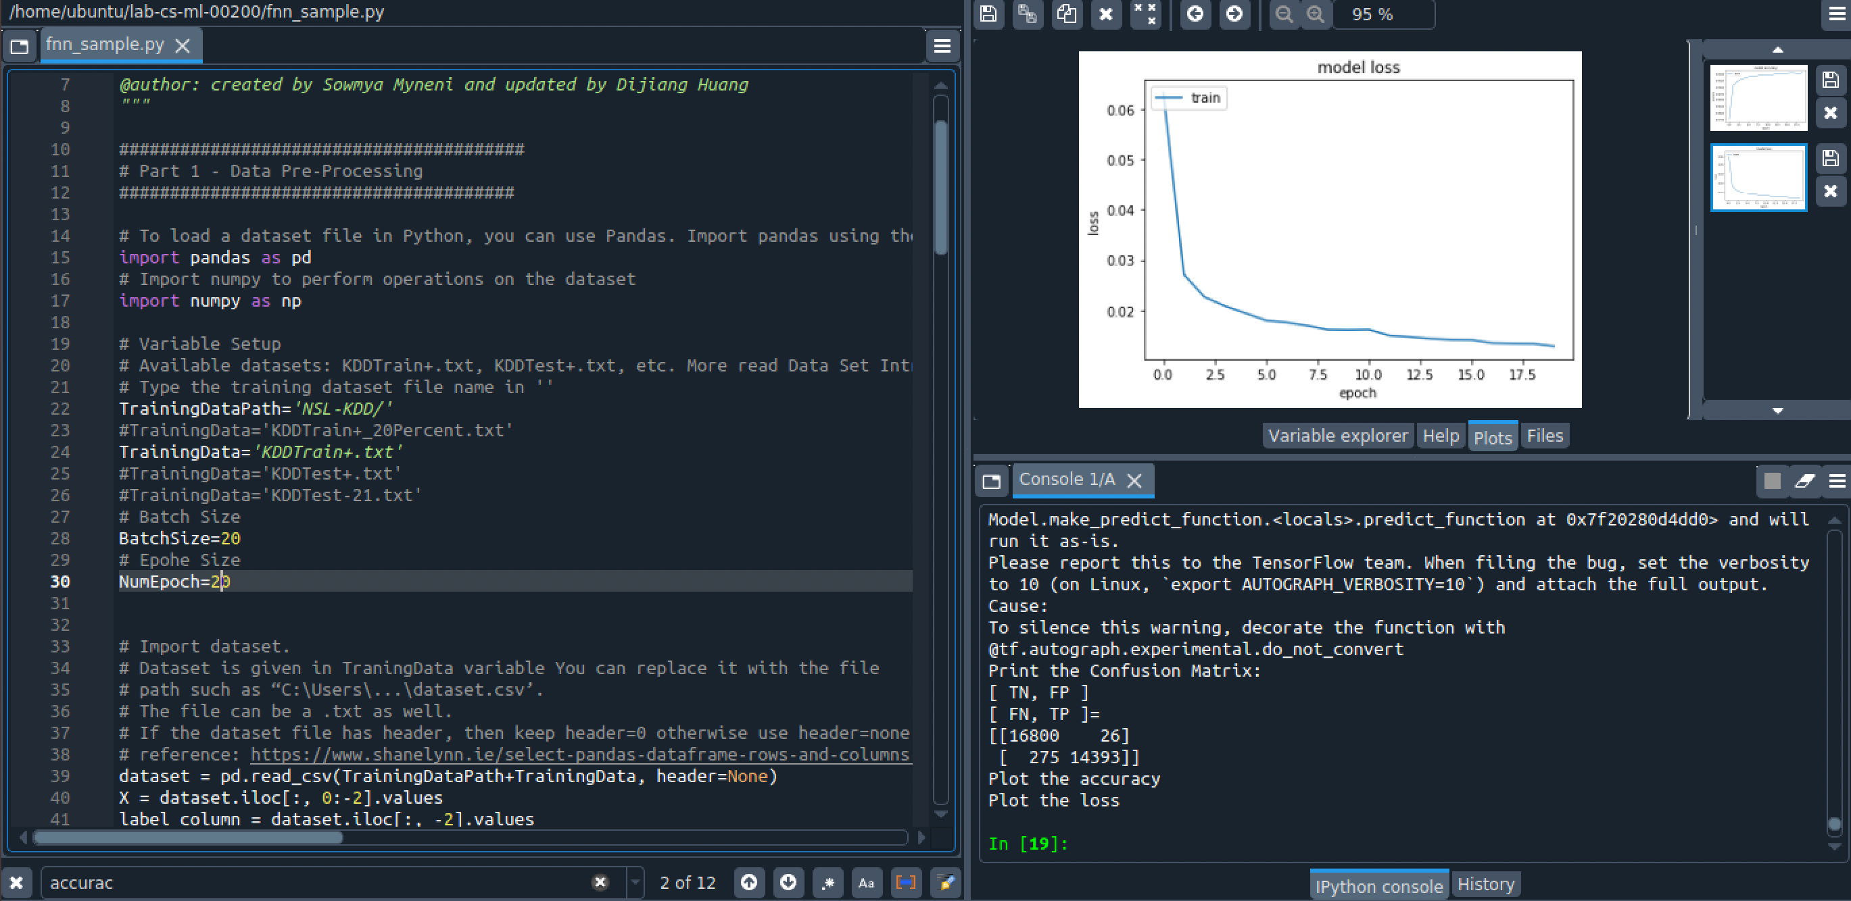

It is very easy in this way to collect the results and observe the differences from the various datasets. For instance, it is obvious to observe that accuracy increases with each epoch run:

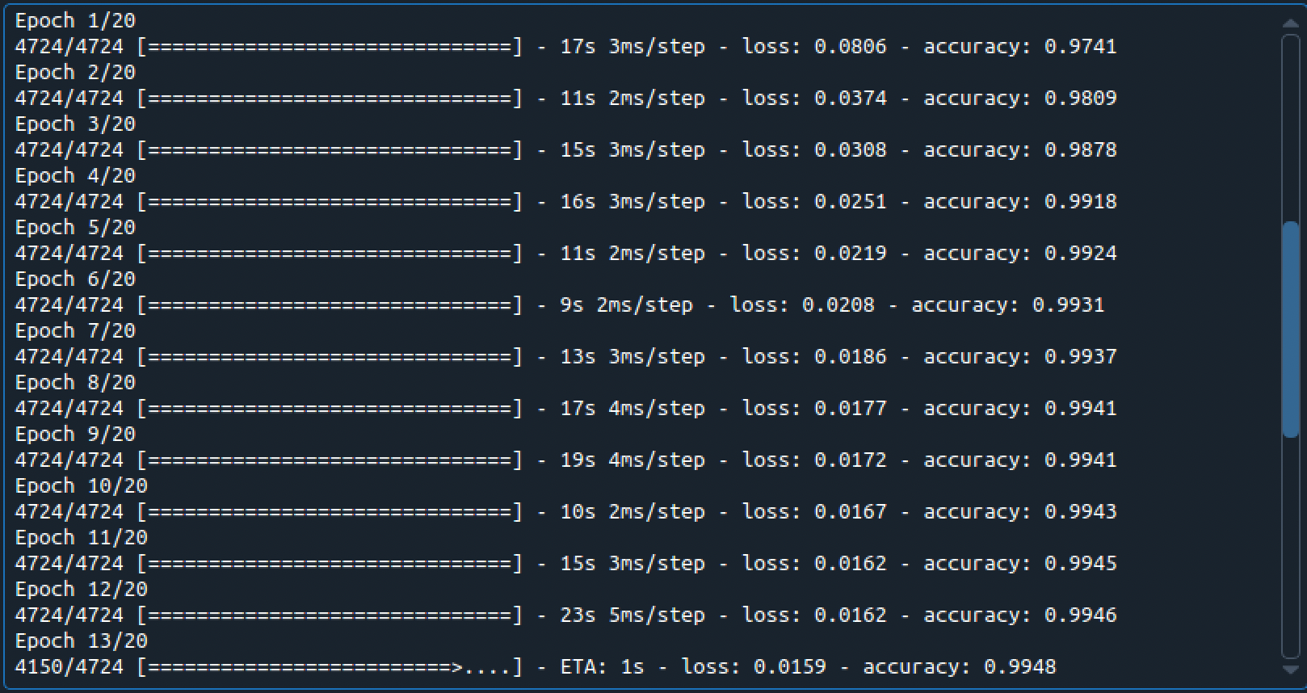

The followings are the results obtained by running the detection on the various datasets.

KDDTrain+: Loss 0.0221, Accuracy: 0.9912

Confusion Matrix: TN=16806, FP=20, FN=533, TP=14135

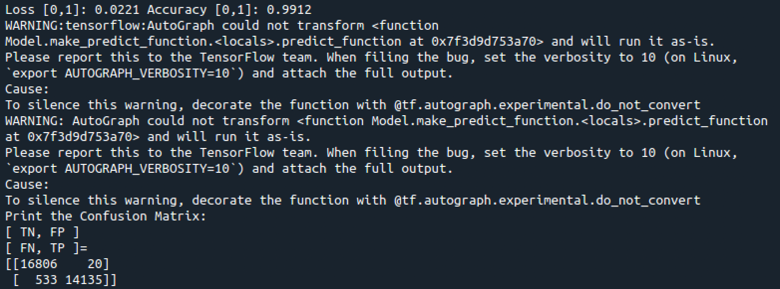

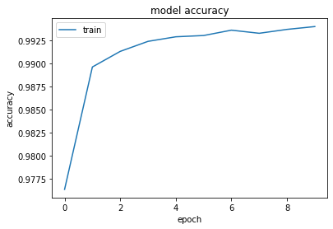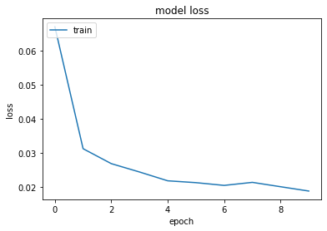

KDDTrain+20Percent: Loss 0.0319, Accuracy: 0.9835

Confusion Matrix: TN=3386, FP=1, FN=174, TP=2737

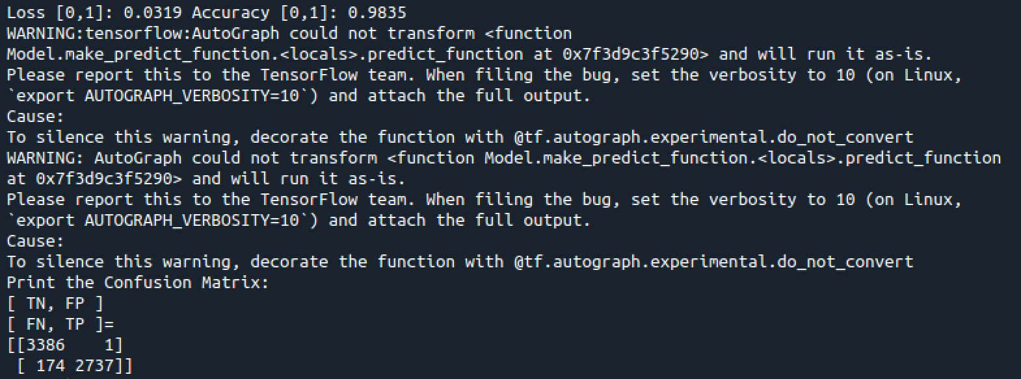



KDDTest+: Loss 0.0675, Accuracy: 0.9683

Confusion Matrix: TN=2486, FP=18, FN=356, TP=2776

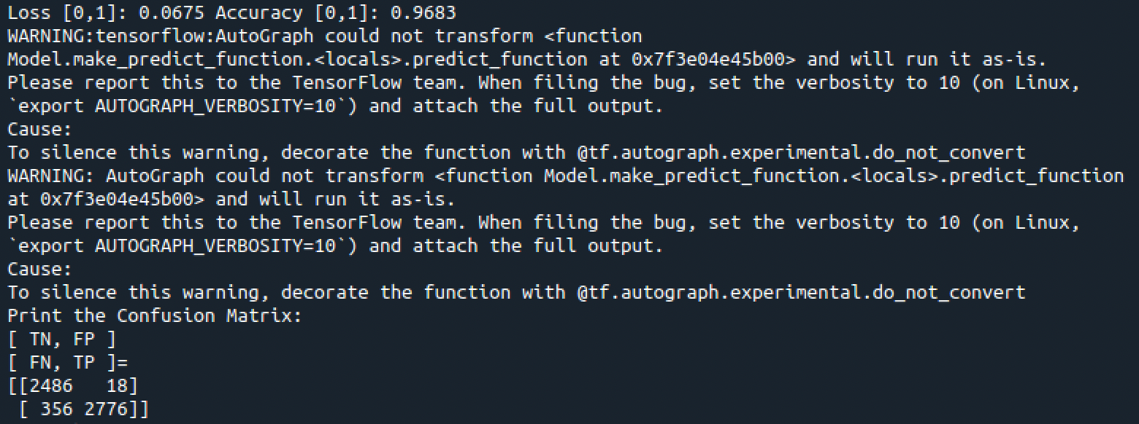

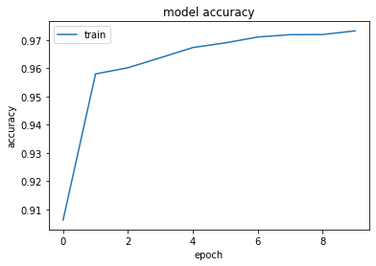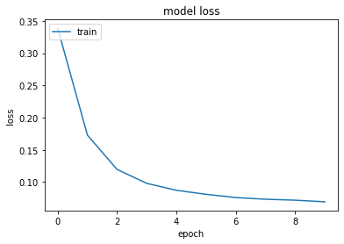

KDDTest-21: Loss 0.1338, Accuracy: 0.9487

Confusion Matrix: TN=550, FP=16, FN=342, TP=2055

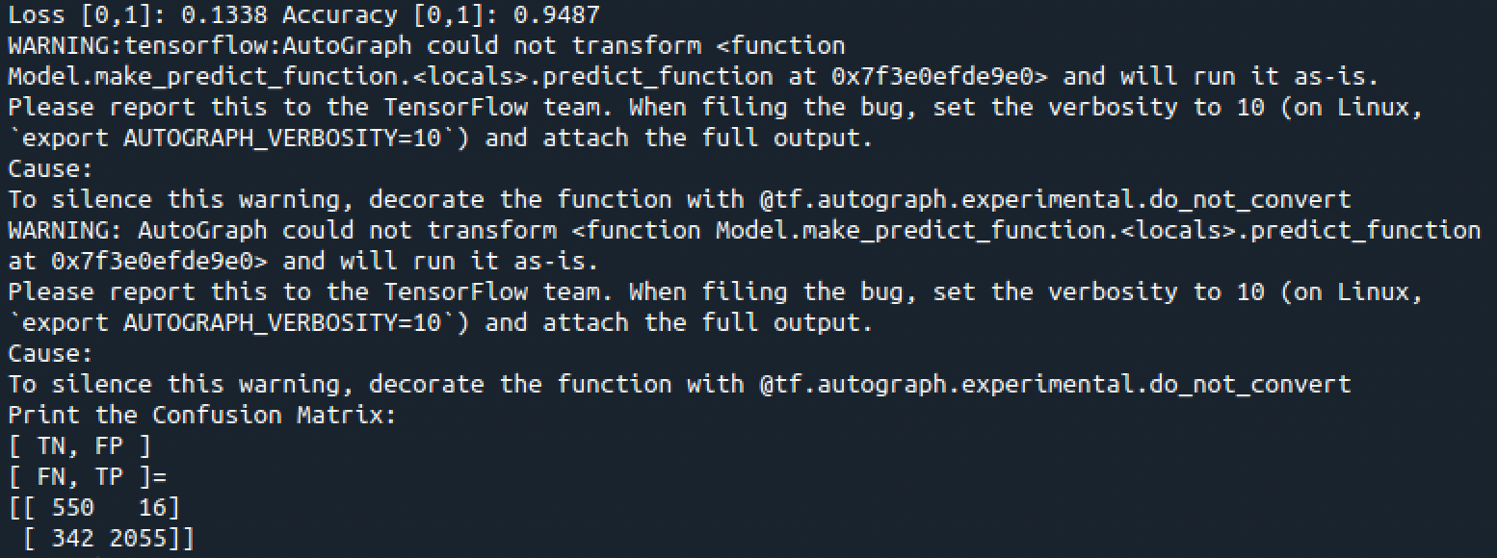

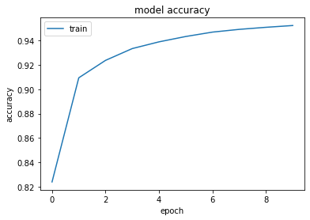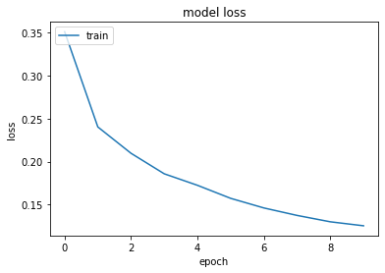

### Comparing the datasets:

In this case, the training set has even a bigger difference against the test data, since the latter have the most difficult traffic record (score of 21) excluded from the training, which means it has less quality input to train with.

Again, the training dataset provides more accuracy and less loss since it has a bigger set of data.

In this case a training dataset provides more accuracy and less loss since the test is smaller.

In this case a much bigger dataset (KDDTrain+) provides a superior accuracy and minor loss.

**KDDTrain+_20Percent.txt vs. KDDTest-21.txt**

KDDTrain+: Loss 0.0221, Accuracy: 0.9912

Confusion Matrix: TN=16806, FP=20, FN=533, TP=14135

KDDTest-21: Loss 0.1338, Accuracy: 0.9487

Confusion Matrix: TN=550, FP=16, FN=342, TP=2055

**KDDTrain+.txt vs. KDDTest+.txt**

KDDTrain+: Loss 0.0221, Accuracy: 0.9912

Confusion Matrix: TN=16806, FP=20, FN=533, TP=14135

KDDTest+: Loss 0.0675, Accuracy: 0.9683

Confusion Matrix: TN=2486, FP=18, FN=356, TP=2776

**KDDTest+.txt vs. KDDTrain+_20Percent.txt**

KDDTest+: Loss 0.0675, Accuracy: 0.9683

Confusion Matrix: TN=2486, FP=18, FN=356, TP=2776

KDDTrain+20Percent: Loss 0.0319, Accuracy: 0.9835

Confusion Matrix: TN=3386, FP=1, FN=174, TP=2737

**KDDTrain+.txt vs. KDDTrain+_20Percent.txt**

KDDTrain+: Loss 0.0221, Accuracy: 0.9912

Confusion Matrix: TN=16806, FP=20, FN=533, TP=14135

KDDTrain+20Percent: Loss 0.0319, Accuracy: 0.9835

Confusion Matrix: TN=3386, FP=1, FN=174, TP=2737

## Run the provided fnn sample.py python program with different one NSL-KDD dataset: KD- DTrain+.txt as the input and compare their detection accuracy with a different neural network setup. Explain your observations.

The fnn_sample.py has been modified as required, as shown below.



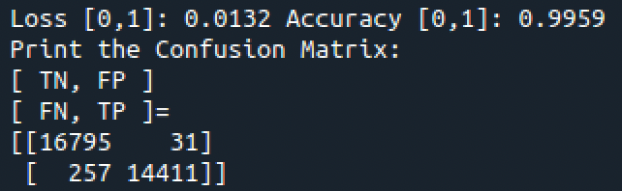

A run with an increased depth of the FNN (more layers) and increased epoch seems to increase the accuracy and diminish the loss – which is expected.

The run with the increased value has ran much slower – it could be perceived although I have not measured precisely.

Interestingly enough, while the TN and TP have increased, so they are the FP – albeit the FN have diminished. So, surprisingly, it seems that not all the results have not improved. It would be interesting to investigate the reason for it (although it is out of scope for this lab).

**KDDTrain+.txt (1st run) vs. KDDTrain+.txt (2nd run)**

KDDTrain+ 1st run: Loss 0.0221, Accuracy: 0.9912

Confusion Matrix: TN=16806, FP=20, FN=533, TP=14135

KDDTrain+ 2nd run: Loss 0.0132, Accuracy: 0.9959

Confusion Matrix: TN=16795, FP=31, FN=257, TP=14411

In the second lab (CS-ML-00301), I use basic FNN model to create an anomaly detection model for network intrusion detection.

## Task 2: Create Data Modules for Anomaly Detection

First of all, I create the datasets using DataExtractor.py. The datasets are all available on the GitHub repository.

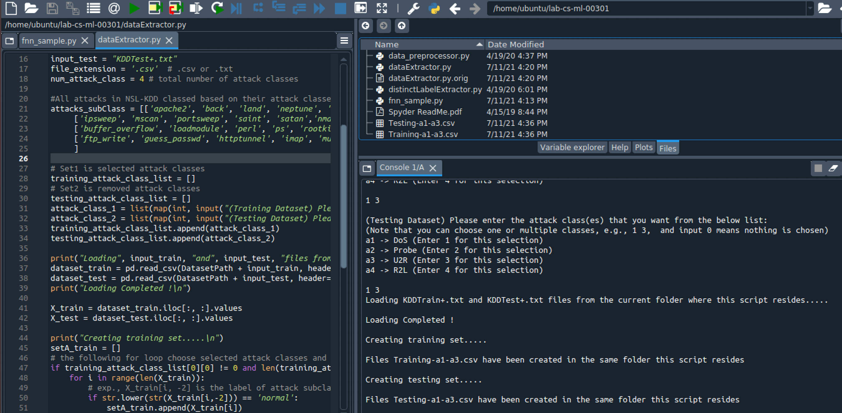

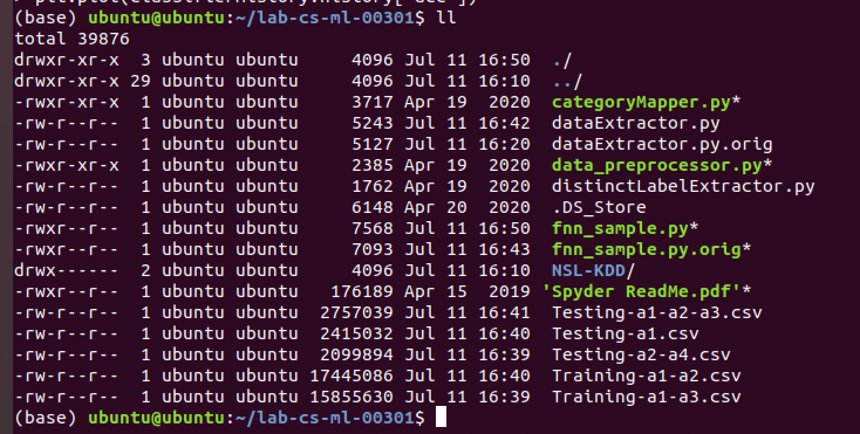

## Lab Assessment

### Using the lab screenshot feature to document ML running results only. Provide sufficient but concise explanations on the generated results for each given training/testing scenarios.

The followings are the results from the three scenarios.

#### **Scenario A**: Loss=0.0052, Accuracy=0.9988, Confusion Matrix: TN=8701, FP=1010, FN=2502, TP=2804

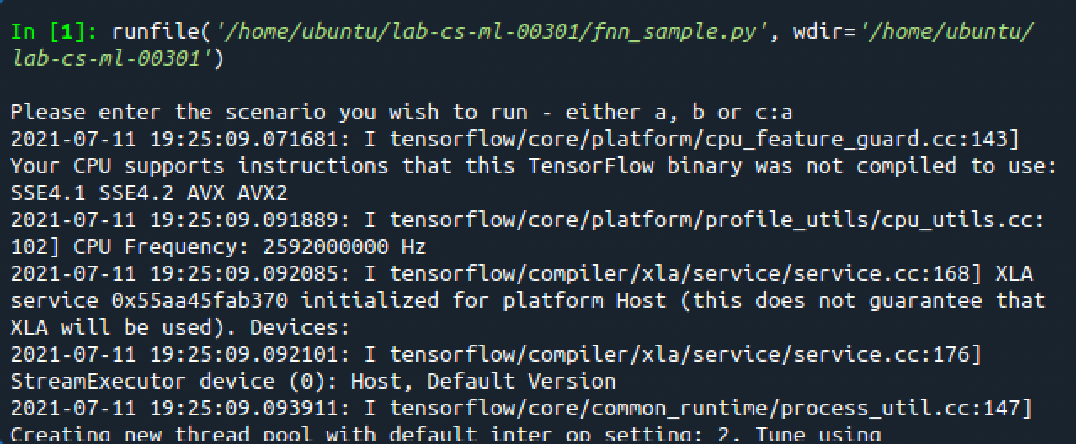

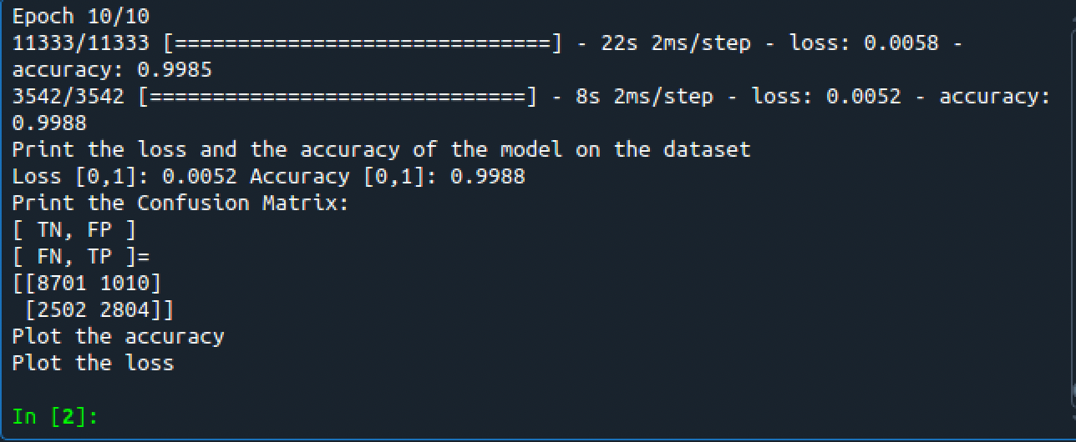

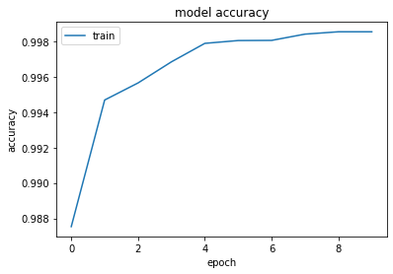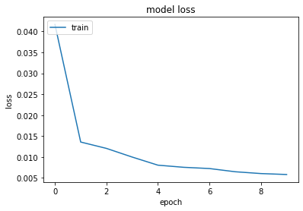

**Explanation of Scenario A**: this scenario uses “DoS” and “U2R” attacks as training and “Probing” and “R2L” attacks in the test cases. Basically, there is no overlap between the training and test cases, and therefore we would expect this scenario to be the one that is worst performing.

Although it is true that this Scenario produces the worst result in terms of Confusion Matrix – surprisingly enough, it is not the worst performer on the Loss and Accuracy values, meaning that the dataset used for training it is probably not very far from the test cases. This can likely be attributed to a certain level of overlapping between the behavior of the different attacks – for instance, a buffer overflow pattern observed amongst the U2R can also be seen during certain DoS attacks.

#### **Scenario B**: Loss=0.0449, Accuracy=0.9905, Confusion Matrix: TN=8840, FP=871, FN=1074, TP=6386

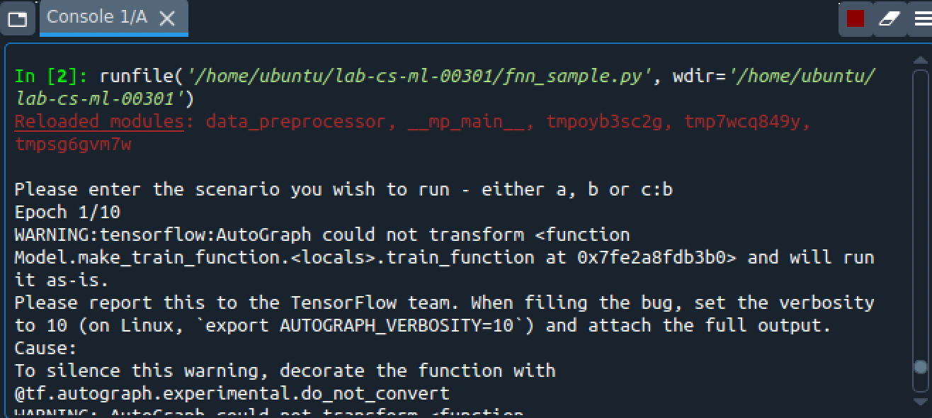

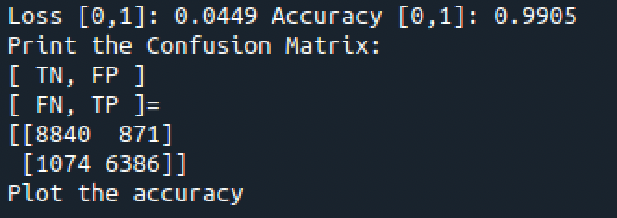

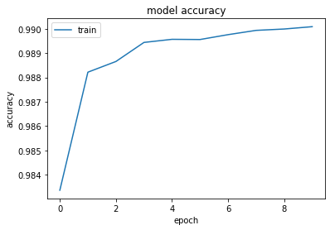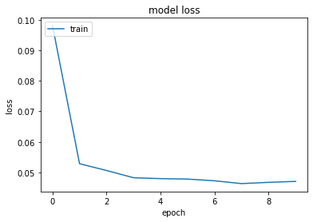

**Explanation of Scenario B**: this scenario uses “DoS” and “Probe” attacks as training only “DoS” attacks in the test cases. Basically, there is a complete overlap between the training and test cases, as the training includes all the attacks that will be found in the test, and therefore we would expect this scenario to be the one that is performing better.

What we observe instead, is that the Confusion Matrix is much better than Scenario A – where we detect as many as three times the True Positives – but with worst Loss and Accuracy. Furthermore, general results are inferior to Scenario C.

Most likely, since this scenario uses less data for the Test compared to Scenario C, it has less possibilities to perform better and detect more attacks, causing an overall worst performance.

#### **Scenario C**: Loss=0.0127, Accuracy=0.9967, Confusion Matrix: TN=8872, FP=839, FN=1295, TP=8653

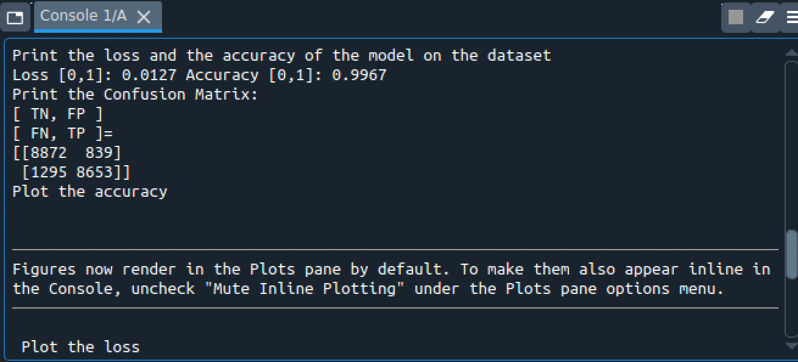

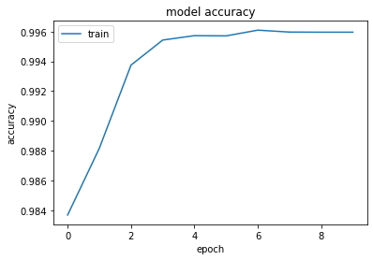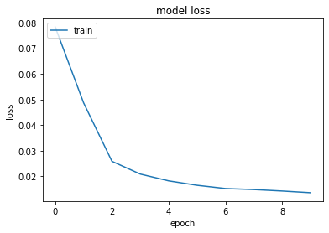

**Explanation of Scenario C**: this scenario uses “DoS” and “Probe” attacks as training (exactly like Scenario 2) and is presented with “DoS”, “Probe” and “R2L” attacks in the test cases. This Scenario is the one that is fed with the biggest number of tests, and it can be therefore the reason why performances seem to be superior to the other Scenarios for what concerns the Confusion Matrix. However, it is inferior to Scenario A for what concerns Loss and Accuracy, which is to be attributed to the fact that there is a class of attacks (“R2L”) for which it is not trained.

### Submit the updated fnn simple.py and provide sufficient comments to illustrate your updated codes.

All the codes shown in the pictures below are available on GitHub, as well as in the provided ZIP file.

My first change is that I have modified fnn_sample.py so that it takes one of the three scenarios (A, B, C) as input. Selecting the scenario will automatically select the respective datasets.

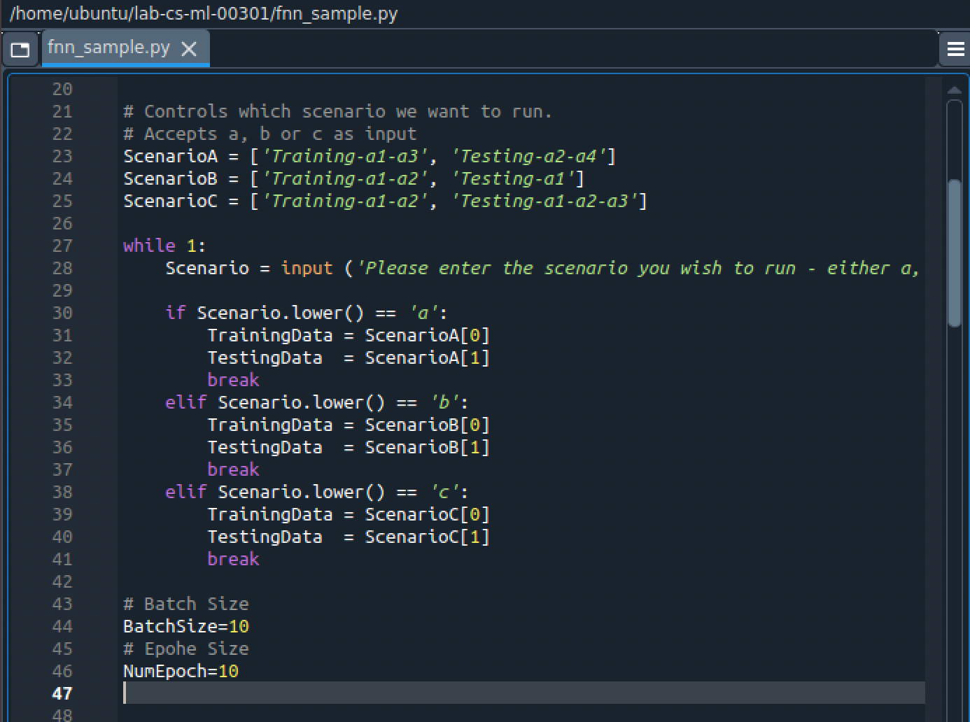

From line 56 up to the implementation of the FNN, I have implemented the code that loads the two pre-processed set (training and test) and then commented out all the code that creates the “hot” split of test and training data, as this is not necessary.

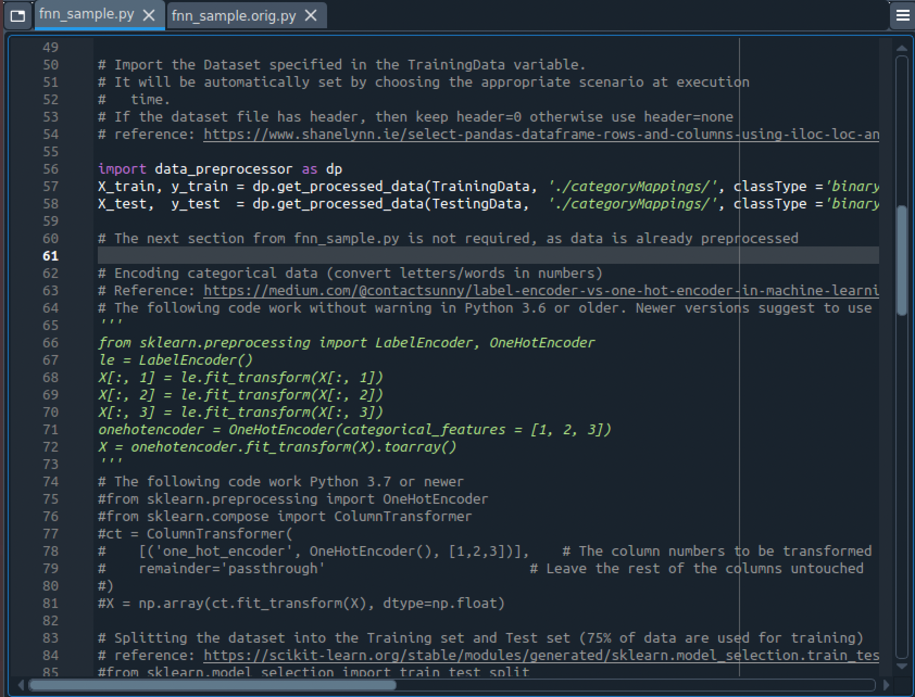

From line 98 (after the comment “Part 2: Building FNN”), the code is basically unmodified.

## Task 3: Anomaly detection analysis

1. The scenario producing the best results is Scenario C. As already described above, there seems to be a better outcome when the sets used in the Test are also present in the Training, which is unsurprising.
2. The average accuracy between Scenario A and Scenario C is 0.99775.
3. As noticed, when a Scenario is presented with attacks for which it has not been trained, it will perform worst in terms of Accuracy and Loss, as it to be expected. However, this does not automatically translate into more attacks blocked.
4. The R2L and U2L use similar patters – for instance they are mostly using TCP protocol as they must transmit an exploit, deposit a rootkit or being transported via HTTP.

Another issue is determined by the fact that “U2R” and “R2L” attacks are numerically much inferior to “DoS” and “Probe” attacks, which reflects negatively on the training.

# Appendix A: Files for the Lab

Please find the list of files created for this lab and mentioned throughout this document, plus their GitHub link for download.

The overall GitHub directory for the project is: <https://github.com/markoer73/CSE-548/tree/main/Project%202%20-%20SDN-Based%20Stateless%20Firewall>

|  |  |
| --- | --- |
| Project Report 4 - Machine Learning-Based Anomaly Detection Solutions.docx | <https://github.com/markoer73/CSE-548/blob/main/Project%204%20-%20Machine%20Learning-Based%20Anomaly%20Detection%20Solutions/Project-Report-4%20-%20Machine%20Learning-Based%20Anomaly%20Detection%20Solutions.docx> |
| fnn_sample.py | <https://github.com/markoer73/CSE-548/blob/main/Project%204%20-%20Machine%20Learning-Based%20Anomaly%20Detection%20Solutions/CS-ML-00301/fnn_sample.py> |

# References

Data preprocessing:

* <https://www.shanelynn.ie/select-pandas-dataframe-rows-and-columns-using-iloc-loc-and-ix/>
* <https://medium.com/@contactsunny/label-encoder-vs-one-hot-encoder-in-machine-learning-3fc273365621>
* <https://scikit-learn.org/stable/modules/generated/sklearn.model_selection.train_test_split.html>
* <https://scikit-learn.org/stable/modules/preprocessing.html>

Build ANN:

* <https://machinelearningmastery.com/tutorial-first-neural-network-python-keras/>
* <https://machinelearningmastery.com/rectified-linear-activation-function-for-deep-learning-neural-networks/>
* <https://machinelearningmastery.com/adam-optimization-algorithm-for-deep-learning/>
* <https://machinelearningmastery.com/how-to-choose-loss-functions-when-training-deep-learning-neural-networks/>

Contents

I. Network Setup 1

II. Software 1

III. Project Description 1

1. Run the provided fnn sample.py python program with different NSL-KDD datasets as the input, and compare their detection accuracy 2

a. Comparing the datasets: 5

2. Run the provided fnn sample.py python program with different one NSL-KDD dataset: KD- DTrain+.txt as the input and compare their detection accuracy with a different neural network setup. Explain your observations. 6

3. Task 2: Create Data Modules for Anomaly Detection 7

4. Lab Assessment 7

a. Using the lab screenshot feature to document ML running results only. Provide sufficient but concise explanations on the generated results for each given training/testing scenarios. 7

b. Submit the updated fnn simple.py and provide sufficient comments to illustrate your updated codes. 11

5. Task 3: Anomaly detection analysis 12

IV. Appendix A: Files for the Lab 13

V. References 13